1. ms01 - List the order number, customer name and order date for all orders later than March 17th, 2015 that do not include '1957 Ford Thunderbird', or the '1992 Ferrari 360 Spider red'. Order by the customer name in ascending order, then the order date in descending order. Returns 24 rows.
2. select **orderNumber**, customerName, **orderDate**from orders  
   where **orderDate** > '2015-3-17'  
   except  
   inner join products using(productName)
3. rl02 – List the customers who share the same postal code. Make sure that no pair of customers shows up more than once.  Ignore customers with no postal code.  Order by the first customer name, then the second. Returns 35 rows.

SELECT A.**CUSTOMERNAME**, B.**CUSTOMERNAME** FROM CUSTOMERS A INNER JOIN CUSTOMERS B  
USING (**POSTALCODE**)  
WHERE A.**POSTALCODE** = B.**POSTALCODE** AND  
 A.**CUSTOMERNAME** != B.**CUSTOMERNAME** AND  
 A.**CUSTOMERNAME** > B.**CUSTOMERNAME**order by A.**CUSTOMERNAME**, B.**CUSTOMERNAME**;

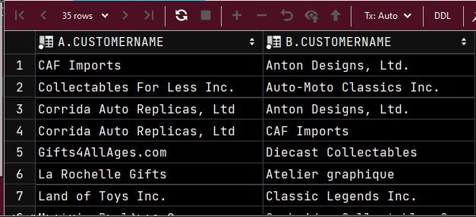

1. rs04 – List the last name and the first name of each employee who reports to a manager who reports directly to the one employee who does not report to anyone (their reportsTo column is null). Order by last name, then first name. Returns 4 rows.

select e.**LASTNAME**, e.**FIRSTNAME** from EMPLOYEES e  
left outer join employees ee on e.**REPORTSTO** = ee.**EMPLOYEENUMBER**where ee.**REPORTSTO** =   
 (select **EMPLOYEENUMBER** from EMPLOYEES  
 where **REPORTSTO** is null);

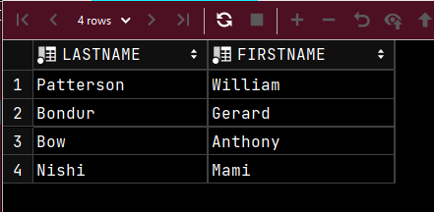

1. ns03 – List the product name, quantity ordered, order date, and customer name for every product order in which the quantity ordered of that product in that order beat the average quantity ordered of that particular product by 40 or more. Order by the quantity ordered, descending. Returns 4 rows.
2. select **productName**, **quantityOrdered**, **orderDate**, **customerName** from customers  
   inner join orders using (**customerNumber**)  
   inner join orderdetails using (**orderNumber**)  
   inner join products using (**productCode**)  
     
   where **quantityOrdered** >  
    (select avg(**quantityOrdered**)  
    from orderdetails  
    inner join orders using(**customerNumber**)  
    inner join customers using(**customerNumber**)) + 40  
   order by **quantityOrdered** desc;

* not correct, can’t get the quantity ordered of the actual product, but it’s close

1. so02 – List the last name and first name of all employees, indicating whether they are managers or not. For those who are managers, the third column of your report should read “Management”. For the rest of the employees, that third column should read “Member Technical Staff”. Remember that the Employees table has the reportsto column to indicate the employee number of the Employee that they report to. If a given employee number never shows up in reportsto for any employee, that means that no one reports to that employee. List the employees ordered by last name, then first name. Return 23 rows.